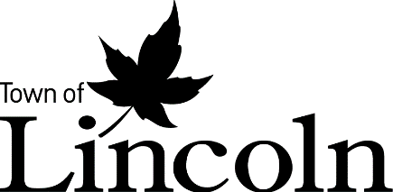
Subject: | Unlocking Lincoln’s Tourism Sector, Creating a Destination Marketing Organization for the Town of Lincoln
To: | Committee of the Whole – Planning & Economic Development
From: | Office of The Chief Administrative Officer

Report Number: | AD-13-23
Wards Affected: | All
Date to Committee: | December 6, 2023
Date to Council: | December 13, 2023

Recommendation:
That Report AD 13-23 regarding Unlocking Lincoln’s Tourism Sector, Creating a Destination Marketing Organization for the Town of Lincoln be received for information; and
That the Mayor and Town Clerk be authorized to execute a Service Level Agreement with the City of St. Catharines on the establishment of a joint Destination Marketing Organization (“DMO”); and
That Committee recommends Council approve a contribution from the Town of Lincoln levy of $75,000 in new, additional funding for the Destination Marketing Organization in 2024, and that this approval be submitted to the 2024 Budget process; and
That Committee recommends Council approve, in principle, an ongoing levy contribution to the new Destination Marketing Organization until such time the Municipal Accommodation Tax will ensure financial sustainability for the organization, pending a yearly review of the Destination Marketing Organization’s KPIs and planned activities; and
That the Mayor and Town Clerk be authorized to execute an agreement with the new Destination Marketing Organization respecting the financial accountability required to ensure that all monies given to the DMO be used for the sole purpose of promoting tourism.

Purpose:
As directed by Council in the 2020 Tourism Strategy and Action Plan, this report provides Council with recommendations around creating a new Destination Marketing Organization for the Town of Lincoln. Thereby supporting one of the most important sectors of our local economy, mainly, agriculture and value-added agriculture as it related to our tourism and hospitality sector.

Background:
What is a Destination Marketing Organization?
Destination Marketing Organizations (DMOs) are globally recognized organizations that work to promote and market tourism for specific geographic locations, communities, or regions. Throughout Canada, DMOs are not-for-profit organizations that promote tourism in their regions. They generally rely on funds generated by municipalities through both levy contributions and/or funding through Municipal Accommodation Tax programs.
Benefits of the Tourism Economy:
There are many benefits to a community that is supported by the work of a DMO. Some of these benefits include:
- Establishing a competitive edge: Developing the destination’s attractions and resources in a way that highlights its authenticity and characteristics will enable it to thrive. Ensuring positive visitors’ experiences, allowing tourists to push their limitations and venture outside their comfort zone, will deliver an excellent quality experience in a destination.
- Ensuring sustainability: Income generated from tourism can stimulate the destination’s development of new infrastructure and community services, upgrade the skills of rural workers, and provide funds for natural, cultural, and historical resources to be managed in a more sustainable way. As a result, visitors will receive more authentic and engaging experiences–all while knowing they are having a positive impact on the destination. Additionally, good destination management can help avoid social and cultural conflicts and prevent tourism from negatively affecting local values.
- Building a tourism culture in the destination: Communicating with the local community in a destination and listening to residents’ voices is necessary to sustaining a tourism destination in the long term. DMOs are responsible for engaging local communities to ensure that tourism development is a mutual benefit between tourism stakeholders and residents in the destination and is something both the municipality and the DMO can undertake. This strategy is also vital for DMOs to preserve the cultures of destinations.
- Building a strong brand identity: DMOs increasingly realize that the value of a destination brand is strongly linked to the value of the destination. Without diversifying the destination’s tourism sources, it is almost impossible to understand who the target market is and what that market needs. Therefore, brand identity is an essential driver to implement successful marketing strategies to the target market. By consistently conveying brand loyalty, tourists regularly return to the destination and become “free advertising” for a DMO: sharing with friends the value they saw in a destination, far beyond the time they spent in it.
- Financial Benefits: when visitors spend money within a destination, the economic benefit it represents supports both tourism-related businesses, but also the public at large. Through the implementation of a Municipal Accommodation Tax, tourism money can be flowed into community beautification and other amenities, such as roads and parks, that benefit both the visitor and the local resident. In addition, when tourism thrives, the businesses that employ our local population also thrive. Private sector investment, i.e., creation of more jobs and economic growth, supports our local economy, helping to pay for the services and programming that municipalities provide.
Timelines – How did we get here?
Timeline | Milestone
2017- 2019 | Council approves an Economic Development Strategy that identifies Tourism and Hospitality as our greatest opportunity for economic growth and job creation.
June 2020 | Council approves the Town’s first ever Tourism Strategy that identifies the need for a new Destination Marketing Organization and the need for a new destination brand for Lincoln.
September 2020 | MOU with the City of St. Catharines to support tourism-related businesses get through the pandemic. MOU also identified the potential for a joint DMO for our communities.
October 2021 | Town of Lincoln approves the new Niagara Benchlands as our tourism destination brand.
December 2021 | St. Catharines and Lincoln begin joint work with Floor13 on the formulation of a joint DMO, extensive stakeholder consultation is conducted.
February 2023 | Council supports the ongoing work of creating a joint DMO with the City of St. Catharines, a shared service on destination promotion and marketing.  Council also approves $75,000 for the 2023 fiscal year to support joint-marketing initiatives
November 2023 | Final Recommendation Report to Council on the creation of the DMO and financial plan.

Twenty Valley Tourism Association
For approximately twenty years, the Town has outsourced tourism development, marketing, and destination management to the Twenty Valley Tourism Association (TVTA), officially our DMO. The Town in the past has supported the TVTA on an annual basis with both financial and in-kind support to assist with their activities. While the TVTA had success over the past two decades, a lack of stable funding and the onset of the 2020 global COVID-19 pandemic forced the organization to cease activities. Due to the importance of tourism to our community, economic development staff took the organization under our wing and began operating as the DMO to support pandemic related relief around destination marketing, but also working with upper levels of government to bring funding to both our tourism and non-tourism related businesses.
While the Board of Directors of the TVTA continues to meet through the assistance of Town of Lincoln staff, the organization has not had a public face since early-2020. Through this extensive process, the recommendation is to revamp the TVTA into the new DMO, using the existing legal structure, albeit with more stable funding, a new name, and with our partners in the City of St. Catharines at the table as both a financial partner and a co-lead throughout this process.

Report:
Introduction
Tourism is a top economic sector in Lincoln. Increased visitation through tourism supports economic development, job growth, and private sector investment ensuring that all of Lincoln will benefit from tourism through the jobs it creates, and the property taxes that our tourism and hospitality pays, which offsets residential property taxes. In addition, the overall beautification and private sector investment that occurs because of tourism is a net benefit supporting both our residents and visitors alike.
Within this report are key market trends that point to a growth in tourism in Lincoln and within the surrounding areas, showcasing the potential for further economic growth and job creation that comes with increased visitation. The trends are promising, Lincoln is gaining momentum and market share, specifically because of our Tourism Strategy and the adoption of our new destination brand, the Niagara Benchlands.
The Council-endorsed Town of Lincoln Economic Development Strategy & Action Plan included the direction to develop the Lincoln Destination Tourism Strategy and Action Plan 2020 – 2025, which in turn identified DMO development as a priority. For approximately 20 years, the Town outsourced tourism development and management to the Twenty Valley Tourism Association (TVTA), officially our DMO. Through extensive consultation, the Town determined that a new third-party organization is needed to help drive destination marketing and product development, spurring further tourism growth and ultimately economic growth in Lincoln.
Tourist expenditure contributes significantly to the local economy. The demand for services in the hospitality sector generates employment opportunities, reducing unemployment rates and providing a stable source of income for residents. A joint-destination organization between the Town of Lincoln and the City of St. Catharines holds the potential to amplify these positive impacts.
Market Trends and Demand Analysis
Lincoln’s tourism sector is on the upswing. Through a detailed analysis of both national, provincial, and regional trends, as well as some local data gleamed from Statistics Canada data, our indicators point towards a growth in tourism both in Lincoln and within our surrounding areas. If cultivated and done right, increased visitation and the economic benefit it brings will result in more jobs for Lincoln as well as more revenue for the municipality, which is represented through the increase in property taxes because of more private sector investment, but also through the revenue from a Municipal Accommodation Tax.
The trends are promising, and Lincoln is gaining market share in the Niagara visitor spend.
As demonstrated in Figures 1 and 2 below, the Ontario tourism industry stands as a pivotal component of Canada's economic landscape, contributing significantly to job creation, revenue generation, and community development. Ontario is forecasted to grow tourism revenues to $98 billion by 2027.
Figure 1: Ontario tourism industry workforce and revenue trends
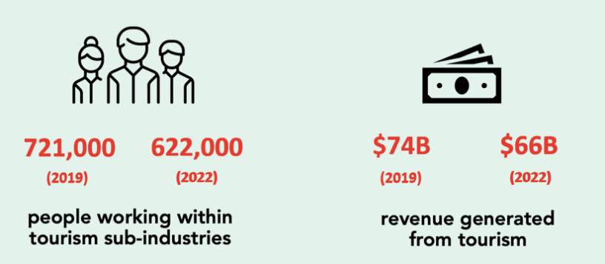
Source: State of the Tourism Industry: Workforce and Revenue Trends, Challenges and Opportunities for 2024, OTEC & CBRE

Figure 2: Economic and Labour Forecast Model for Ontario
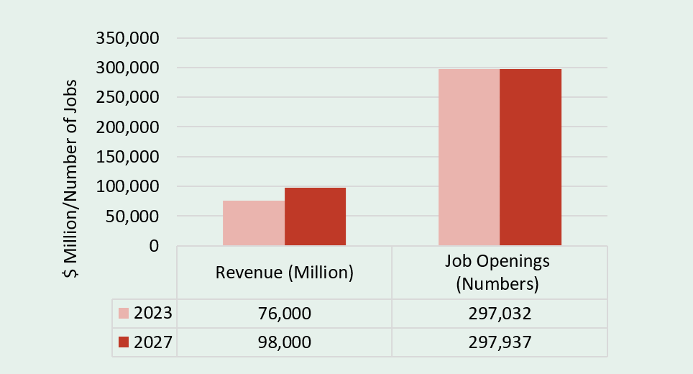
Source: Destination Dynamics: Local, Economic and Labour Forecast Model. OTEC-CBoC. October 2023. Table: Labour Supply Model, Employment Flows & Revenue
There is no doubt that tourism expenditures were substantially impacted by the COVID-19 Pandemic. In the table below, 2020 and 2021 expenditures in Niagara and Lincoln were not recorded during the pandemic years. Nevertheless, the data below are an estimate extrapolated from the regional data by considering Lincoln’s share of tourism jobs across the Region and associated expenditures by industry. Based on these estimates, the Town of Lincoln tourism expenditures in 2022 have rebounded from the COVID-19 pandemic, reaching the same expenditures levels as pre-pandemic.
Most significantly, Lincoln has also seen an increase in total market share from 2016-2022 based on these estimates. While expenditures in Niagara region overall have stayed constant, expenditures in Lincoln have increased by over 20% from 2016 – 2022. This means that when people travel to the Niagara region, more people are choosing to travel to Lincoln vs other neighbouring communities.
Figure 3: Total tourism expenditures from 2016 – 2022 in Lincoln and the Niagara Region
Area | 2016 | 2017 | 2018 | 2019 | 2020 | 2021 | 2022
Niagara | $2,110,458,000 | $2,362,164,000 | $2,148,668,000 | $2,358,415,000 | n/a | n/a | $2,124,176,000
Lincoln | $88,034,839.07 | $98,437,782.13 | $99,524,136 | $110,701,592 | n/a | n/a | $108,947,272
Source: Statistics Canada, National Travel Survey, and Visitor Travel Survey

Tourism Jobs in Lincoln

Tourism jobs are defined from the Canadian Tourism Satellite Account (CTSA), which measures the impact of tourism in the Canadian economy. The CTSA includes industries such as accommodations, food services, restaurants, and recreation services, to name a few. For Lincoln we have also included beverage manufacturing as a key tourism industry, as we know it’s impact on Lincoln’s tourism economy is great.

Based on the data, Lincoln has seen a steady increase in tourism-based jobs from 2013-2023. The number of tourism jobs took a substantial hit in 2020, due to the COVID-19 Pandemic. Since 2020, tourism jobs in Lincoln have been increasing and are just below pre-pandemic levels. Even with the impact of the pandemic, total jobs in the tourism industry have increased by 26.2% over the past decade.

Figure 4: Total tourism job numbers in Lincoln from 2013-2023 based on the North American Industry Classification System (NAICS codes from the Canadian Tourism Satellite Account (CTSA), including beverage manufacturing.
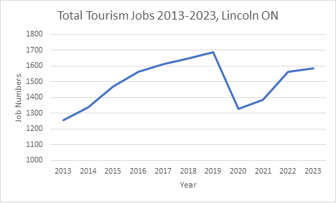
Source: Lightcast 2023

Tourism Businesses in Lincoln

From 2015 – 2023, the Town of Lincoln has seen an increase of 44% in businesses without employees and 25% with businesses with employees for a total of 33% increase in tourism-based businesses during that time frame. As of 2023, Lincoln has a total of 166 tourism-based businesses.

Like tourism jobs, tourism business counts are also defined from the Canadian Tourism Satellite Account (CTSA).

Statistics Canada business counts are also measured by businesses with employees and businesses without employees. Businesses without employees can include Bed & Breakfasts, independent artists and performers, and even small batch beverage manufacturers. While businesses with employees can include large beverage manufacturers, restaurants and eating establishments, and hotels, to name a few.

Figure 5: Total tourism businesses with and without employees from 2015-2023 in Lincoln, ON
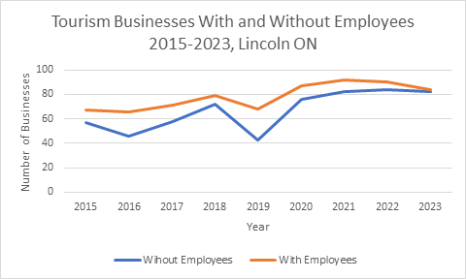

Source: Statistics Canada, Canadian Business Counts

Creating a new DMO for Lincoln
As a community that has agriculture and value-added agriculture, represented by its tourism and hospitality sector, as one of its main economic drivers, it is natural that our community needs a Destination Marketing Organization to help support tourism marketing, which in turn, attracts private sector investment, creates jobs, and supports our overall community as there are many non-tourism related benefits to having tourism in Lincoln.
Through extensive consultation and planning, the recommendation from our consultants is to continue with a third-party organization, like the TVTA, albeit with a more diversified Board of Directors backed by sustainable funding. To save money and time, the recommendation to use the existing legal structure that is the TVTA will be followed, as it does not make sense to recreate a not-for-profit entity when we already have one on hand.
Core Purpose and Objectives of a new DMO for Lincoln
The core purpose of the DMO will be to build brand awareness of the destination by promoting its benefits, merits and experiences to leisure travelers, travel trade, corporate meetings, sports groups and events, and travel media within our markets.
The DMO will have specific objectives that focus on marketing, facilitating product development and advocacy for the tourism industry in Lincoln, with the overarching goal of growing the local economy and creating jobs.
More specifically, the main of objectives of the DMO will be to:
- Promote the Niagara Benchlands destination brand to multiple markets, identifying the region’s unique, authentic, and welcoming nature, through sales and marketing initiatives in partnership with industry and the business community.
- Increase visitation and visitor spending in the Niagara Benchlands via tourism-focused initiatives.
- Foster cross-sector collaboration and promotion.
- Improve visitor experience.
- Increase investment in the local economy by both tourism businesses and festival/event activations.
- Attract high-quality local jobs in alignment with the Economic Development Strategy & Action Plan.
Organizational Structure
The DMO will be comprised of:
- An Industry Board of Directors.
- Staff in key strategic roles who are well equipped fulfill the DMO’s core purpose and objectives.
Figure 6 – Proposed Organizational Structure of the new Joint DMO
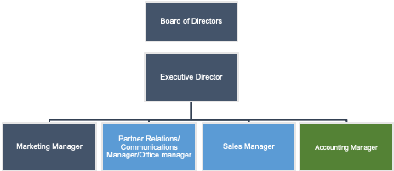

Industry-led Board of Directors
A well-structured Board of Directors is essential for effective governance and decision-making. The Board of Directors should be industry-led and lend their relevant expertise to setting the evolving mandate and goals of the DMO. They should have a vested interest in ensuring the success of the DMO and strengthening Lincoln’s tourism industry and the community’s overall economy and prosperity.

Board Member Term Overview
- Chair - 2-year term. Maximum 2 terms (total of 4 years)
- Board members - 2-year term. Maximum 3 terms (total of 6 years)
- Sub-Committees – Industry-led with 8 industry representatives per committee. Sub Committees include:
  - Finance
  - Marketing & Communications
  - Leisure, Travel Trade
  - Craft Beverage
DMO Staffing
Local DMOs need to be well staffed with individuals that are versed in everything from marketing, sales, accounting, business liaison, and dedicated product development. While it will be the responsibility of the Board of Directors and the Executive Director to develop a staff complement, it is our recommendation that staffing be spaced out to ensure financial sustainability while focusing on deliverables for the two communities. Essentially, staff need to be brought onboard only when revenue matches the expected costs of hiring personnel.
In addition, given that 2024 will be viewed as a “transitional year” for the DMO, permanent staff are not expected to be brought onboard until 2025, this will allow both the transitional Board of Directors and the elected Board of Directors to get the foundational elements in place. The overall administrative management of the DMO will be shared between Town of Lincoln and City of St. Catharines staff to minimize costs for the DMO in Year 1.
Implementation and 2024 Launch Plan
The formation of a new Destination Marketing Organization (DMO) is a significant step towards promoting tourism and economic growth in our community. This plan outlines the steps to launch the organization in 2024, in alignment with Canadian Tourism Best Practices.
Key Milestones and Approximate Timelines
Appoint Transition Board of Directors (Q1 2024)
To ensure a smooth and effective transition, the appointment of a Transition Board of Directors is essential in providing governance, marketing, and tourism expertise, ensuring best practices are adhered to from the get-go, and in initiating appropriate stakeholder engagement. This board will guide the initial stages of DMO formation and alignment with Canadian Tourism Best Practices.
Objectives of the Interim Transition Board:
- Develop the legal and governance framework for the DMO.
- Define the DMO's funding model and secure initial financial commitments.
- Oversee the hiring of key personnel, including a CEO or Executive Director.
- Develop a preliminary marketing and branding strategy.
- Establish an organizational structure, including a board of directors and advisory committees.
- Ensure transparency and community involvement in decision-making.
The Transition Board will operate for a period of 10 months, ensuring a smooth transition into full DMO operations. A budget will be allocated for the Interim Transition Board's activities, which will include legal consultations (if required) and initial marketing efforts.
The appointment of a Transition Board is a critical step in establishing a DMO. This board will provide the expertise and guidance necessary to ensure the DMO's alignment with Canadian Tourism Best Practices and set the foundation for successful destination marketing, economic growth, and community development.
Pre-Launch Preparation (Q1 2024):
Legal and Governance Framework:
- Establish a legal framework for the DMO, including its constitution, bylaws, and organizational structure.
Funding Model:
- Develop a sustainable funding model for the DMO, considering a mix of public and private sources.
- Secure initial funding commitments from stakeholders.
Organizational Development (Q2 2024):
Governance and Advisory Structure:
- Define the roles and responsibilities of the board of directors, including subcommittees.
Marketing & Communications Strategy (Q3 2024):
DMO Communications:
- Develop a communications strategy for the DMO, that reflects the unique messaging for both communities.
Marketing Plan:
- Develop a comprehensive marketing strategy and annual plan. Begin content creation, including website development, promotional materials, and social media content plans.
- Identify key target markets and segments for marketing campaigns.
Launch and Initial Promotion (Q4 2024):
DMO Launch Event:
- Organize a joint launch event.
- Invite local community members, stakeholders, and media to introduce the DMO.
Early Marketing Campaigns:
- Launch initial marketing campaigns to build awareness and encourage early engagement.
- Offer promotional packages and incentives for visitors to visit our destination.
Annual General Meeting (Q4 2024)
The inaugural Annual General Meeting (AGM) of the Destination Marketing Organization (DMO) in the fall of 2024 marks a pivotal moment in the DMO's establishment for the Town of Lincoln and the City of St. Catharines. This event will elect an industry-led Board of Directors.
Staffing (2025)
- Recruit and hire an Executive Director with expertise in destination marketing and management.
Financial Projections / Revenue Streams
Destination Marketing Organizations are not-for-profit organizations run by a volunteer Board of Directors that must adhere to Ontario’s Not-for-Profit Corporations Act, 2010. The Act provides Ontario’s not-for-profit corporations with a modern legal framework to meet the needs of today’s not-for-profit sector. This includes how the corporations are to be created, governed, and dissolved. In addition, there are legal requirements around financial disclosures as well as financial obligations that the corporation must adhere to.
While the new DMO will be a third-party organization run by an independent Board of Directors, it is the Town’s perspective that the organization must adhere to the Act, but also ensure proper accounting principles so that they are living within their means.
As such, a Six-Year estimated revenue forecast has been devised to assist in both short-term and long-term financial planning, as activities must match the revenue being brought in. Given the variability of these estimated projections, each fiscal year the Board of Directors and the Executive Director must ensure their annual budget considers the natural ebb and flow of funding, especially as it related to the Municipal Accommodation Tax. Below is a list of anticipated revenue sources for the DMO. The Six-Year estimated revenue forecast is broken down as an appendix to this document.
Revenue Streams
Annual Destination Travel Guide
- Development of an annual Destination Travel Guide for the DMO will promote our local businesses, showcasing what our destinations offer.
- This guide will support the DMO’s destination marketing goals by providing a valuable resource for travelers.
- Local businesses will need to pay to be listed on the local guide, this is a nominal subscription fee but opens the businesses up to other promotional and marketing activities of the DMO.
Grants
- The DMO will be expected to seek funding opportunities from various levels of government and organizations that support DMOs and tourism marketing.
- Because of the Not-for-profit status of the DMO, they will be able to go after funding that isn’t available to municipalities.
Marketing Investment Programs
- Private-sector tourism-based businesses can expect various benefits by participating in marketing programs being offered by the DMO.
- These programs are designed to promote the destination, attract visitors, and boost the local tourism industry – thus generating revenue for both the DMO and local businesses.
- When fully operational and running, these marketing programs tend to be a large source of revenue for the DMO.
Sponsorships
- Sponsorship revenue serves as a valuable source of diversified funding. It complements municipal contributions, offering a dynamic financial resource that can be tailored to specific initiatives or campaigns. Sponsorship revenue ensures that the DMO has access to additional financial support beyond traditional funding sources.
Municipal Subsidies
- The DMO requires a stable and diversified source of funding to effectively execute its mission and deliver tangible benefits to the community. While the DMO's objectives align with the Town's vision, it must ensure ongoing operational expenses and activities match the funding it receives.
- To ensure long-term sustainability of the organization, municipal contributions are essential, and this can take the form of levy contributions, Municipal Accommodation Tax contributions, or a combination of both.
Risks and Mitigations
Destination Marketing Organizations (DMOs) often face revenue variability from multiple sources, including Municipal Accommodations Tax (MAT), private sector investments, sponsorship, grants, and subsidies. To ensure financial stability and minimize the impact of revenue fluctuations, a comprehensive risk mitigation and solution strategy is essential.
“According to a 2020 survey by Destination Analysts, budgets for DMOs have fallen by nearly 60% on average in Canada and 40% in the US. Of necessity, DMOs have taken on a range of new roles to support their local industry — securing emergency funding, finding alternative revenue streams, taking on a stronger advocacy role, advising tourism businesses on government grant and funding applications, and more.”
Source: Tourism’s Big Shift: Key Trends Shaping the Future of Canada’s Tourism Industry, November 2021: Destination Canada.
It is suggested that the following Risk Mitigation Strategies be considered by the DMO for long-term success:

Diversify Revenue Sources:
- Private Sector Investments and Sponsorship: Over-reliance on one or two private sector investments or sponsors can be risky. Diversify the portfolio of private sector investors and sponsors to spread the risk.
- Grants and Subsidies: Seek grants and subsidies from a variety of sources, including government agencies, private foundations, and non-profit organizations. Diversification in grant sources reduces dependency on a single grantor.
- Develop Reserves: Create financial reserves during periods of surplus revenue to act as a buffer during lean years. This approach helps maintain financial stability when certain revenue sources fluctuate.
- Revenue Forecasting: Implement robust revenue forecasting and monitoring systems to track revenue streams in real-time. Regularly assess the performance of each revenue source to detect potential issues early.
- Contingency Budgeting: Develop contingency budgets that account for revenue variability. Set aside a portion of the budget as a reserve to cover unexpected shortfalls. These reserves should be used sparingly and replenished when revenue exceeds expectations.
- Cost Controls: Implement effective cost control measures to align expenditures with revenue levels. During lean years, prioritize essential activities and limit non-essential spending.
In addition to the noted risk mitigation strategies, it is recommended that DMO also employ the future-focused strategies below, to proactively strengthen the organization over time:
- Partnership Diversification: Seek new private sector investments and sponsors to diversify income sources. Strengthen relationships with existing sponsors while actively pursuing new ones. Collaborate with private sector stakeholders on mutually beneficial initiatives.
- Grant and Subsidy Applications: Maintain an ongoing dialogue with grantors and subsidy providers to explore opportunities for funding. Develop compelling grant proposals that align with the DMO's mission and objectives.
- Maturation of Revenue Streams: Recognize that certain revenue streams, such as sponsorship, private sector investments, and MAT, may take time to mature and stabilize. Continue nurturing these relationships and invest in long-term partnerships.
- Strategic Budget Adjustments: In response to revenue variability, consider revising the budget to prioritize critical activities. Focus on initiatives that align with the DMO's core mission and objectives.
- Communication and Transparency: Maintain open communication with stakeholders, including private sector investors, sponsors, and grantors. Transparency regarding revenue fluctuations, challenges, and mitigation strategies can foster understanding and support.
- Ongoing Evaluation: Regularly review the effectiveness of the risk mitigation and solution strategies. Adjust these strategies as needed to adapt to changing market conditions, financial dynamics, and the evolving needs of the DMO. By actively managing revenue variability and taking proactive measures, the DMO can maintain financial stability and achieve its mission.

Expected Outcomes for the Lincoln Tourism Economy
The desired future state envisions the highly successful development, implementation, and operation of the DMO. Ultimately, the goal of establishing a sustainably funded DMO is to elevate awareness of, and interest in, the destination within key markets and amongst targeted visitor segments, leading to quantifiable growth in visitations, visitor spending, investment attraction and positive economic impact. ​
Leveraging the Niagara Region’s worldwide brand recognition, the new Lincoln and St. Catharines DMO will represent this area’s many authentic products and experiences as distinct and unique to the area. In its early stages, the DMO will leverage St. Catharines’ urban vibe, attractions, and hotel community, complimented by Lincoln’s rural attractions, authentic nature, and our wineries, breweries, and distillers.
The expected outcomes are tied directly to the objectives outlined above.
- Heightened brand awareness locally, regionally, nationally, and internationally, making the Niagara Benchlands a destination of choice.
- Increased revenues to continue to fund the DMO and Town initiatives, further fueling the local tourism economy.
- Recognition of the Niagara Benchlands as a leader in tourism excellence in Canada.
- Improved and expanded collection of amenities, experiences, and attractions that leverage tourism in the region.
- A destination of choice for tourism businesses and festival & event planners, with high-quality amenities to support these activities.
- A skilled and diverse workforce employed at high-caliber jobs, contributing to a robust and healthy local economy.

Financial, Legal, Staff Considerations:
Financial:
During the 2023 budget deliberations, Town of Lincoln Council approved a dedicated fund of $75,000 to support the development of the new Destination Marketing Organization and for direct marketing support to help promote the Niagara Benchlands. This funding went a long way towards ensuring the foundational documentation to get the DMO launched is in place. In addition, the funding supported destination marketing and joint-initiatives with the City of St. Catharines, recognizing that the burgeoning relationship and joint-marketing will help lay the groundwork for the new DMO.
To support the overall launch of the new Destination Marketing Organization, staff are requesting that an additional net new levy contribution of $75,000 be approved in the 2024 budget to support the launch and activities of the DMO. By combining with the base budget approved in 2023, the combined $150,000 contribution to the DMO will support the activities of the organization until such time as the MAT program can be up and running to support the activities of the DMO. It is our opinion that the new DMO should be funded predominately, if not wholly, by MAT. As the MAT revenues increase, levy contributions to the DMO will decrease. However, we recognize that ongoing financial support could be an additional requirement but will only be considered on a case-by-case basis.
In Appendix B a detailed Six-Year revenue forecast is presented. It is imperative that the DMO match spending and activities with the revenue it receives. This will ensure the long-term financial sustainability of the organization.
It is our recommendation that the Town of Lincoln ensure the overall success of the organization through committed levy contributions over a five-year period, with levy contributions decreasing as our MAT contribution increases on a year-over-year basis. By year six, based on MAT revenue projections, the requirement to fund the DMO through the levy will be removed.

Staffing:
As 2024 is a transition year for the DMO, it is recommended that both staff from the Town of Lincon and the City of St. Catharines share overall administration of day-to-day DMO operations, until at which time the organization is financially secure to hire a full-time, permanent Executive Director.
Legal:
All draft legal documents as it pertains to the formulation of the new DMO, as well as our service level agreement with the City of St. Catharines and our Financial Accountability Agreement with the new DMO, will be reviewed by both legal teams of the respective municipalities.

Public Engagement Matters:
Throughout the entirety of this project, dating back to the development of the 2020 Tourism Strategy and Action Plan, the development of a new DMO for Lincoln, in partnership with the City of St. Catharines, has been shared and communicated throughout both communities. Support for this project is widespread as the benefit of the joint-DMO will be shared in both municipalities.

Conclusion:
An investment in Lincoln’s tourism economy is an investment in the entire community. With the proper investment and strategies in place, including the DMO, we can expect to see multiple community and economic benefits and a continued high quality of life for Lincoln’s residents. When Lincoln sees an increase in tourism spending, private sector investment, and job creation, all of Lincoln’s residents, whether they work in the tourism sector or not, will benefit from the increased taxation and overall economic well-being of our destination.
The DMO will enable Lincoln’s budding tourism economy to reach its potential and make the Niagara Benchlands a unique and desirable destination for visitors, tourism businesses, and festival and event planners.
A joint Destination Marketing Organization provides the framework for stakeholders in Lincoln to unite their efforts, pool resources, and implement a cohesive strategy to promote the region as a must-visit destination.
By strategically positioning Lincoln within the broader context of Ontario's tourism narrative, the region can tap into the province's extensive marketing channels and benefit from collective promotional campaigns. This collaborative approach not only amplifies the reach of Lincoln's message but also fosters a sense of unity among local businesses, communities, and government entities. As a result, the economic impact extends beyond increased tourism revenue, encompassing job creation, infrastructure development, and a strengthened sense of community pride.
The development of a new DMO is a culmination of much work accomplished to this point, including actions completed from Economic Development Strategy & Action Plan and Lincoln Destination Tourism Strategy and Action Plan 2020 – 2025. These are the building blocks to help grow this sector, and we are poised to move forward.
The trends and data presented demonstrate continued growth and confidence in our tourism sector – both by the local tourism industry and by visitors to our community.
The trends are promising, and Lincoln is gaining market share in the Niagara visitor spend. Our team is adept at pivoting and reacting to factors beyond our immediate control – including the global and national economy. What we can control is how we market the immense potential of Lincoln’s tourism sector by putting the key pieces in place.
This is why investing in the DMO at this time is a crucial next step.
By investing in Lincoln’s tourism sector through the development of a new DMO, we will reap multiple benefits for the future of Lincoln.

Respectfully submitted,

Paul Di Ianni
Director, Economic Development and Communications
pdiianni@lincoln.ca
905-563-2799

Appendices:
Appendix A: Destination Marketing Organization Draft By-law
Appendix B: Estimated DMO Contribution Schedule

Report Approval:
Report has been reviewed and approved by the Chief Administrative Officer.

